

PE-xxxx  
Revision A

MEMS CYCLING AND HOLD DOWN PROCEDURE

Table of Contents

1. Purpose and Scope 3

1.1 Purpose 3

1.2 Scope 3

2. Responsibilities 3

3. REFERENCE DOCUMENTS 3

4. FORMS 3

5. DEFINITIONS (Not Applicable) 3

6. EQUIPMENT AND MATERIALS 4

7. REQUIREMENTS AND PROCEDURES 4

7.1 Basic Hardware, Software, and Environmental Requirements 4

7.2 MEMS Cycling 5

7.3 MEMS Hold Down 5

7.4 Reject Criteria 5

7.5 Set-up and Handling Guidelines 5

7.6 Procedure to SET-UP Test 6, 7

7.7 Procedure to RUN TEST 7 to 13

8. REVISION HISTORY 14

# Purpose and Scope

## Purpose

This document defines the procedures and requirements for cycling and holding down stresses for MEMS capacitors.

## Scope

This procedure applies to the qualification and ongoing production monitoring of all WiSpry products.

# Responsibilities

The Product Engineering function is responsible for assuring compliance to the requirements of this document.

# REFERENCE DOCUMENTS

|  |  |
| --- | --- |
| Document No. | Document Name |
| PE-0002 | Equipment Calibration Procedure |

# FORMS

|  |  |
| --- | --- |
| Form No. | Form Name |
|  |  |

# DEFINITIONS (Not Applicable)

# EQUIPMENT AND MATERIALS

Equipment consists of:

|  |  |  |  |
| --- | --- | --- | --- |
| **Item** | **Model** | **Manufacturer** | **Comments** |
| Computer (equipment controller) | PC with Window XP, 7 | Any |  |
| Software (equipment controller) | LabView 2012 or Higher |  |  |
| GPIB-USB-HS | 778927-01 | National Instruments |  |
| Triple Output Power Supply | E3631A | Agilent/Keysight | w/ GBIP interface |
| Source Meter | 2400 | Keithley | w/ GBIP interface |
| DMM | 2000 | Keithley | w/GPIB interface |
| FPGA | PIX-7813R | National Instruments |  |
| PXI Card Chassis | PIX-1033 | National Instruments |  |
| DUT boards | Various**1** | --- | WiSpry Design |
| SHC68-68-RDIO Shielded Cable | 191667-01 | National Instruments | NI Cables |

Notes:

**1** WS1050 board is 36 positions (model WS-EVB-165)

# REQUIREMENTS AND PROCEDURES

## Basic Hardware, Software, and Environmental Requirements

* Cycling and hold down hardware (boards, cables, connectors, bench equipment) must be able to:
  + Meet the electrical conditions specified in sections 7.2 and 7.3.
  + Meet WiSpry calibration requirements specified in PE-0002.
  + Be sufficiently robust to ensure minimum leakage currents.
* Cycling and hold down software should:
  + Allow for insitu monitoring for stiction events.
  + Meet the electrical conditions specified in sections 7.2 and 7.3.
* Cycling and hold down environmental controls shall:
  + Provide control of temperature and humidity.
  + Meet calibration requirements defined in PE-0002.

## MEMS Cycling

The cycling conditions for product qualification and ongoing monitoring are:

|  |  |
| --- | --- |
| **Stress Condition** | **Requirement** |
| MEMS Operating Voltage (VOP) | 44 V |
| VDD | 3.7 V @ 12 KHz |
| Temperature | 65 oC |
| Frequency | 12 KHz |
| Duty Cycle | 25% |
| Dual Voltage Actuation (DVA) | OFF |
| Beam Actuation | All beams cycles simultaneously |

## MEMS Hold Down

The hold down conditions for product qualification and ongoing monitoring are:

|  |  |
| --- | --- |
| **Stress Condition** | **Requirement** |
| MEMS Operating Voltage (VOP) | 44 V |
| VDD | 3.3 V |
| Temperature | 65 oC |
| Frequency | ---- |
| Duty Cycle | 100% |
| Dual Voltage Actuation (DVA) | OFF |
| Beam Actuation | All beams cycles simultaneously and held for the stress duration |

## Reject Criteria

For both cycling and hold down, the following conditions define a reject reading:

COFF ±46 fF per bank

CON ±657 fF per bank

## Set-up and Handling Guidelines

* Handling recommendations for ESD
* Stabilize oven temperature prior to loading parts, 15 minutes minimum
* Preconditioning of new stress boards (to remove excess moisture absorption), 24 hour bake at 85C
* Optimal method to load boards
* Special software instructions
* Best way to unload parts
* Socket inspection after each run and cleaning/repair as required
* Sample control and storage post stress

## Procedure to Set-up Test

* Fig. 1 below is the test set-up block diagram for WS1050 Reliability Test, Multi DUT
* Using banana plug cables to connect all test equipments as the Fig. 1 below. For power supply E3631A, use channel 1 for VDD, channel 2 for +3.3V.



* Test Program: Using executable of WS1050 36 DUT Reliability HD_Cycling Ver1.4 as the latest test program version for stressing parts
* Fig. 2 below is the front panel of the test program

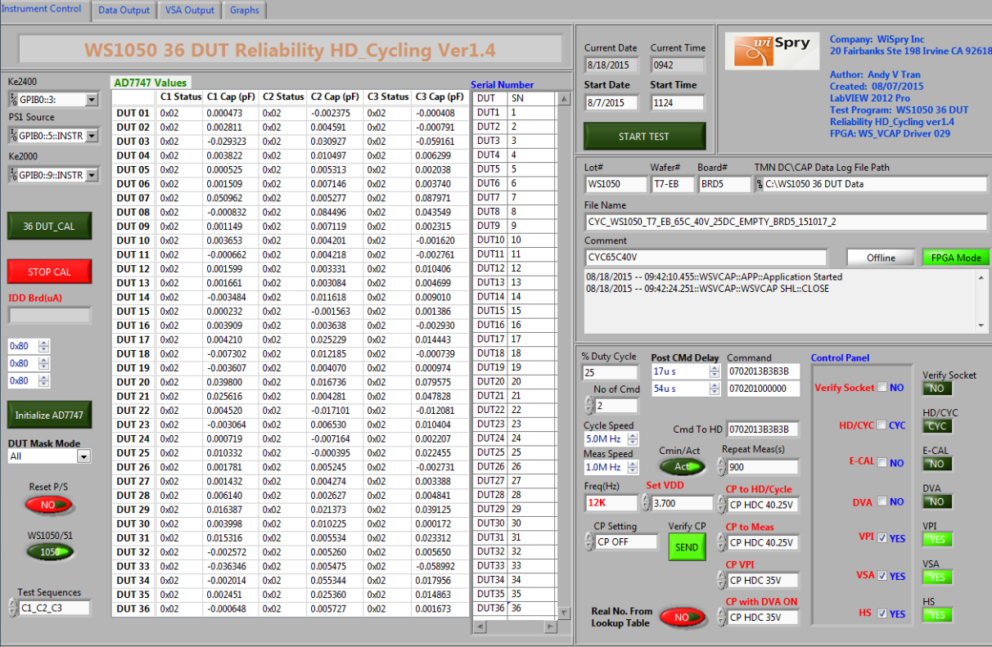

Fig. 2

This test program will be found at the link below:

S:\Software_Control\Released\36 DUT Board\WS1050 36 DUT Reliability HD_Cycling Ver1.4

## Procedure to Run Test

* Set temperature from oven/chamber
* Adjust temperatures from oven/chamber to meet the requirement (25C, 45C, 55C, 65C or 85C)
* Set-up test program
* From labVIEW test program click  this button at the top left corner to run the test program, it will pop-up a dialog box (Fig. 3) below to ask the look up table for read point

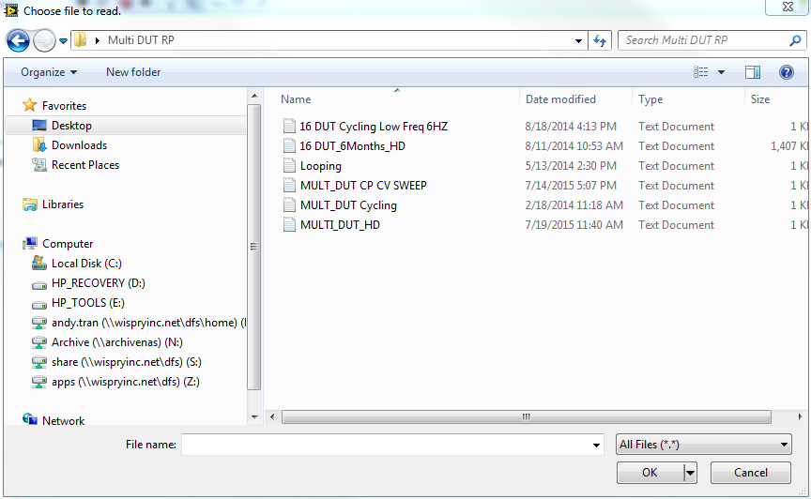

Fig. 3

Note: It depends on what stress you are running to select the correct file.

For instance:

If you are running cycling, the file will be selected is MULT_DUT Cycling

If you are running Hold Down, the file will be selected is MULT_DUT HD

* For calibration (Fig. 4): Make sure all sockets are empty and the CAP values of 36 DUT are around zeros “~0”for all three banks. If not, click on 36 DUT_CAL button  to zero out the sockets, then click STOP CAL button  to stop the calibration

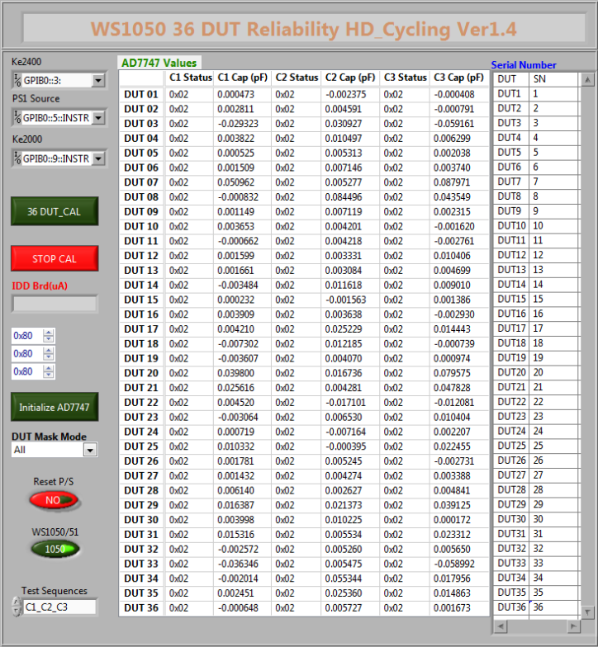

Fig. 4

Note: If sockets are not zeros “~0”, click on initialize AD7747 button  to initialize the ADI chip, make sure the CAP values will be less than 1pF (<1pF) for all three banks of 36 DUT, click on 36 DUT_CAL button to zero out the sockets then click on STOP CAL button to stop the calibration.

* Set-up test condition (Fig. 5): The front panel below was set by default with cycling, DVA OFF, E-CAL OFF, VPI ON, VSA ON, HS (hand shake check) = ON, VDD = 3.7V, cycle speed = 12 KHz, CP stress = 40.25V, CP VPI = 35V.

# 

Fig. 5

# Set-up with standard stress (cycle): All Drivers ON, All Drivers OFF, 25% Duty. Make sure the numbers will be set as same as the boxes are shown below

# 

# Set-up with special stress (cycle): C1 ON, C2 OFF, C3 OFF; C1 OFF, C2 ON, C3 OFF; C1 OFF, C2 OFF, C3 ON, 33% Duty. Make sure all the numbers will be set as same as the boxes are shown below

# 

# Set-up for stress (hold down): All Drivers should be closed during hold down, 100% duty. This was set by default

# Set-up for the data output (Fig. 6): The front panel below is to set-up to collect the test data.

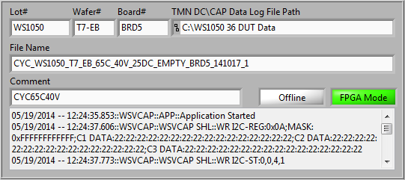

Fig. 6

Note: The file name will be

stress_lot#_wafer#_design_temperature_CPV Stress_duty_brd#_yymmdd_run

* Set-up date/time to run stress (Fig. 7): We can start to run the test immediately by click on the START TEST button, or we can set-up date/time to run the test by enter the Start Date and Start Time

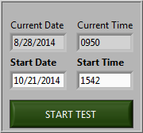

Fig. 7

* The front panel below (Fig. 8) indicates the CAP values for every read point.

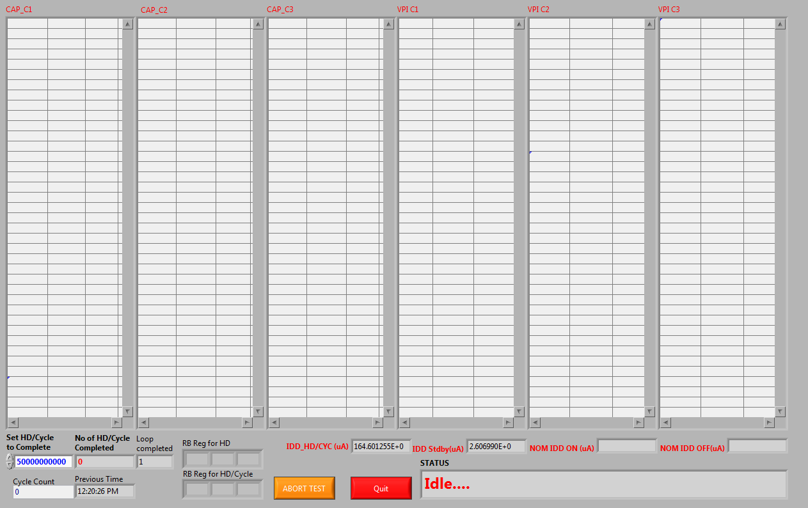

Fig. 8

* The front panel below (Fig. 9) indicates VSA, HS check, EFUSE, % Delta CAP for every read point

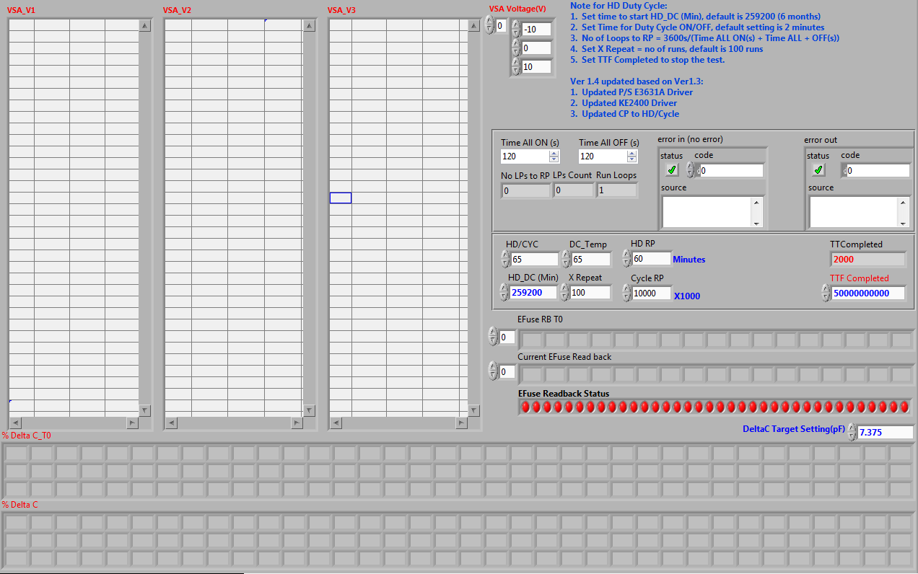

Fig. 9

* The plots below (Fig. 10) monitor the change of CMIN during stress.

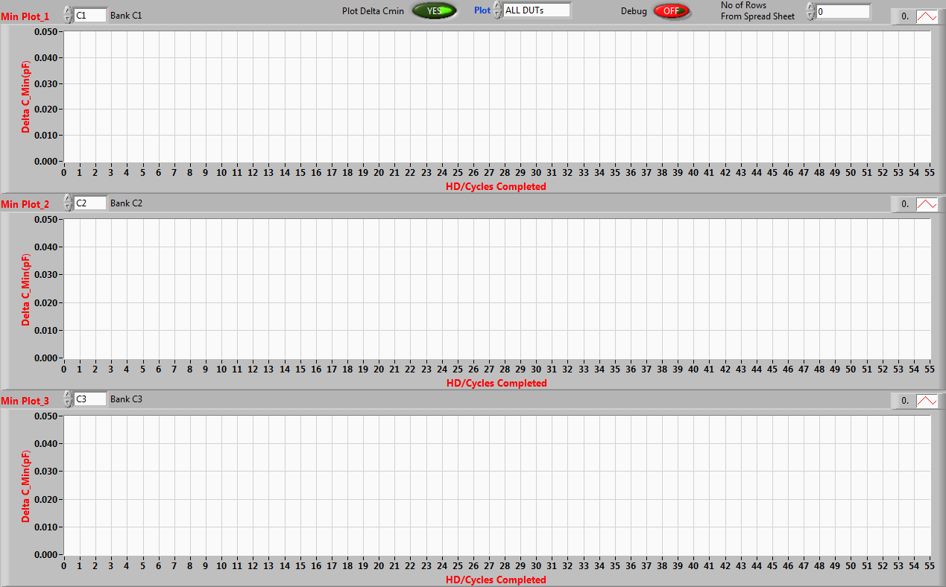

Fig. 10

* Stop stress or abort the test: We can abort the test immediately by click on the ABORT TEST button or enter the number that will be set to complete the test (5 billion cycles is set by default).

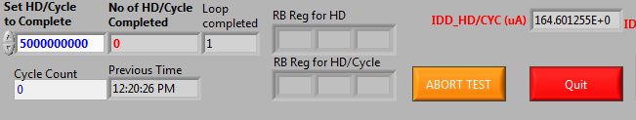

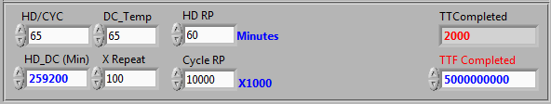

# REVISION HISTORY

|  |  |  |  |
| --- | --- | --- | --- |
| Rev | Description | Editor | Date |
| A | Initial Release | M. Johnson | 12-Aug 2015 |